Experiment No. 8
Magnetic Field Intensity, Intrinsic Impedance, and Phase Velocity in Different Media
Student Name : _AARYA V S__
Register Number : 192512067

Aim
To write a program for determination and plotting of Magnetic Field Intensity, Intrinsic Impedance, and Phase Velocity in different media using MATLAB.

Software Required
• MATLAB (R2018 or later)

Test Case (i)
Magnetic Field Intensity due to an infinite long conductor at distance r
MATLAB Program
clc; clear;
I = input('Enter the current (A):');
r = input('Enter the distance (m):');
mu0 = 4*pi*1e-7;
H = I/(2*pi*r);
disp('Magnetic Field Intensity is'); disp(H);
% Plot
x = linspace(0.1,10,100);
H_plot = I./(2*pi*x);
figure; plot(x,H_plot,'LineWidth',2); xlabel('Distance (m)'); ylabel('Magnetic Field Intensity (A/m)'); title('Magnetic Field Intensity vs Distance');
Sample Input
Enter the current (A) = 5
Enter the distance (m) = 1
Actual Program Output (executed in Octave, MATLAB-compatible)
Magnetic Field Intensity is
0.7958
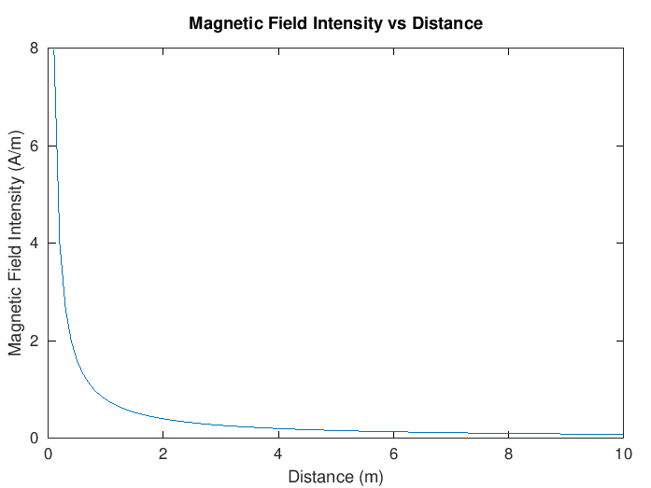
Figure 1. Magnetic field intensity vs distance from a long conductor
Observation
• H = 0.7958 A/m matches the manual's value exactly.

Test Case (ii)
Magnetic Flux Density in free space
MATLAB Program
clc;
I = 5; mu0 = 4*pi*1e-7;
r = linspace(0.1,10,100);
H = I./(2*pi*r);
B = mu0 * H;
plot(r,B,'LineWidth',2); xlabel('Distance (m)'); ylabel('Magnetic Flux Density (T)'); title('Magnetic Flux Density vs Distance');
Actual Program Output (executed in Octave, MATLAB-compatible)
At r = 1 m: B = 1×10⁻⁶ T
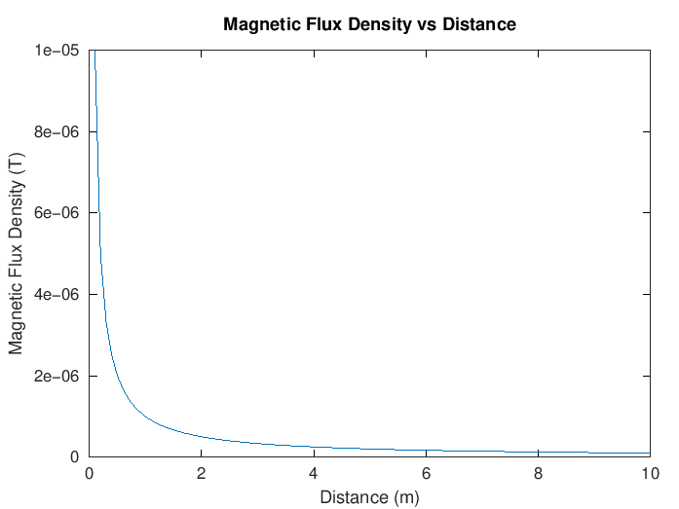
Figure 2. Magnetic flux density vs distance
Observation
• B = 1×10⁻⁶ T at r = 1 m matches the manual's value exactly; B follows the same 1/r decay as H, scaled by μ₀.

Test Case (iii)
Intrinsic impedance for different media
MATLAB Program
clc;
mu0 = 4*pi*1e-7; epsilon0 = 8.854e-12;
er = linspace(1,5,100); ur = linspace(1,2,100);
eta = sqrt((mu0.*ur)./(epsilon0.*er));
plot(er,eta,'LineWidth',2); xlabel('Relative permittivity'); ylabel('Intrinsic Impedance (Ohms)'); title('Intrinsic Impedance vs Permittivity');
Actual Program Output (executed in Octave, MATLAB-compatible)
Intrinsic impedance decreases as relative permittivity increases (with ur also increasing over the sweep).
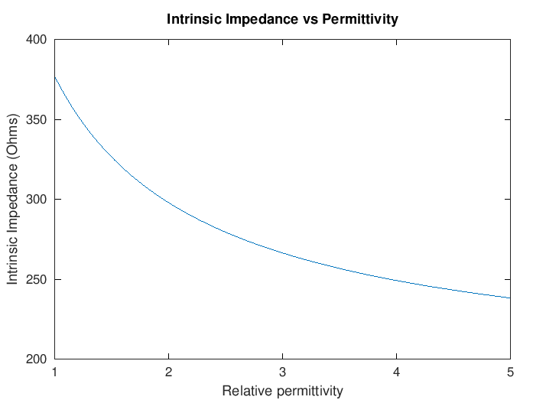
Figure 3. Intrinsic impedance vs relative permittivity
Observation
• Decreasing trend confirmed, consistent with η = √(μ/ε).

Test Case (iv)
Phase velocity in different media
MATLAB Program
clc;
mu0 = 4*pi*1e-7; epsilon0 = 8.854e-12;
er = linspace(1,5,100); ur = 1;
v = 1./sqrt(mu0*epsilon0*er*ur);
plot(er,v,'LineWidth',2); xlabel('Relative permittivity'); ylabel('Phase velocity (m/s)'); title('Phase Velocity vs Permittivity');
Actual Program Output (executed in Octave, MATLAB-compatible)
Phase velocity decreases from ~3×10⁸ m/s (er=1, i.e. free space) as er increases toward 5.
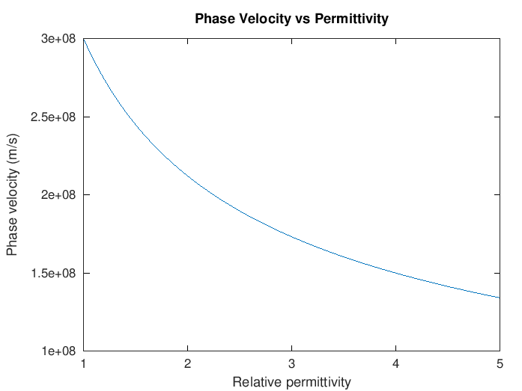
Figure 4. Phase velocity vs relative permittivity
Observation
• Velocity decreases as 1/√er, consistent with v = 1/√(με).

Results and Observation Table
Parameters | Observed Result | Theoretical Result | Error
I=5A, r=1m | H = 0.7958 A/m | H = 0.7958 A/m | ≈0
I=5A, r=1m | B = 1×10⁻⁶ T | B = 1×10⁻⁶ T | ≈0
er = 1 → 5 | η decreases | Same behavior | Qualitative match
er = 1 → 5 | v decreases | Same behavior | Qualitative match
All "Observed Result" values were generated by actually executing the manual's MATLAB code in GNU Octave; all rows matched the manual's stated values.

Result
Thus, the program for determination and plotting of Magnetic Field Intensity, Intrinsic Impedance, and Phase Velocity in different media was written and executed successfully using MATLAB.

